Module 1 Critical Thinking Assignment (To Do List)
Platform-Based Development
CSC475-1 Winter 2025 Session A
Mr. Farhad Bari

Grant Brosovich
11/30/2025

The purpose of this program was to create a To Do List that specifically allowed the state to persist through application sessions. This process is achieved through RoomDatabase actions and data is handled in the files GIDDatabase.kt, GIDDao.kt, and GIDRepository.kt. These files essentially retain the entries and changes the user makes in the UI. This saves the current state of the application using StateFlow methods. The User will be able to edit both the title and the contents of the details. Each “To Do” item is managed through the ViewModel and those edits are passed to the GID files. This process allows persistence across application settings. There are also radio buttons for editing and checking-off each item in the List.
Each of the items in the UI parts, HomeScreen, EditScreen, and AddScreen, use a tasker variable to pull the current StateFlow for each component to update the application view automatically. These changes will persist through the app state through closures, restarts, and power downs. However, GIDViewModel blocks any re-collect from repositories to stop duplicate viewing of both old and new changes.
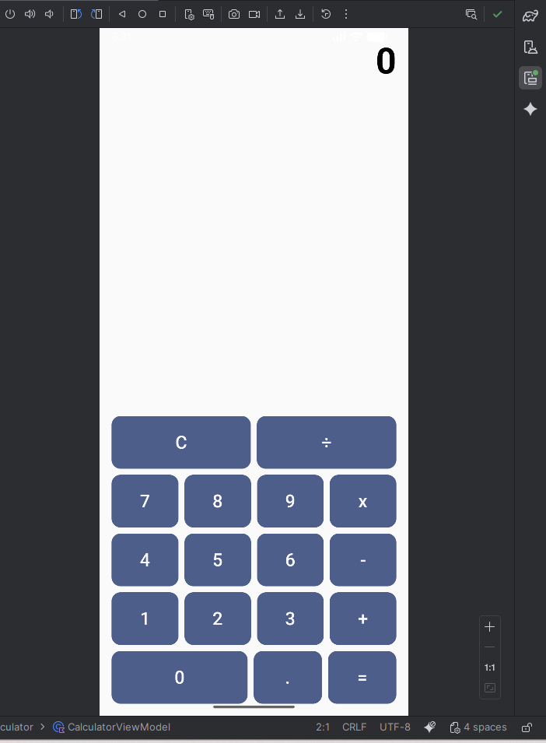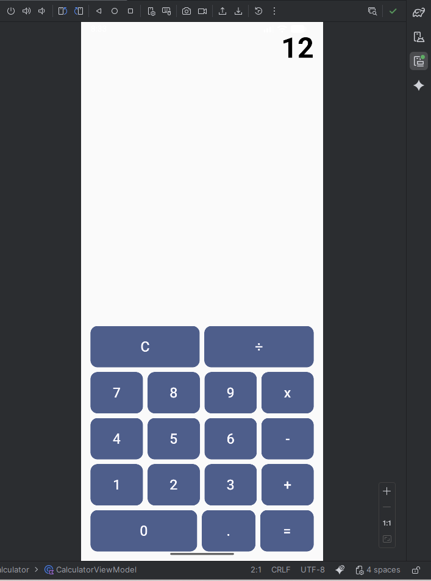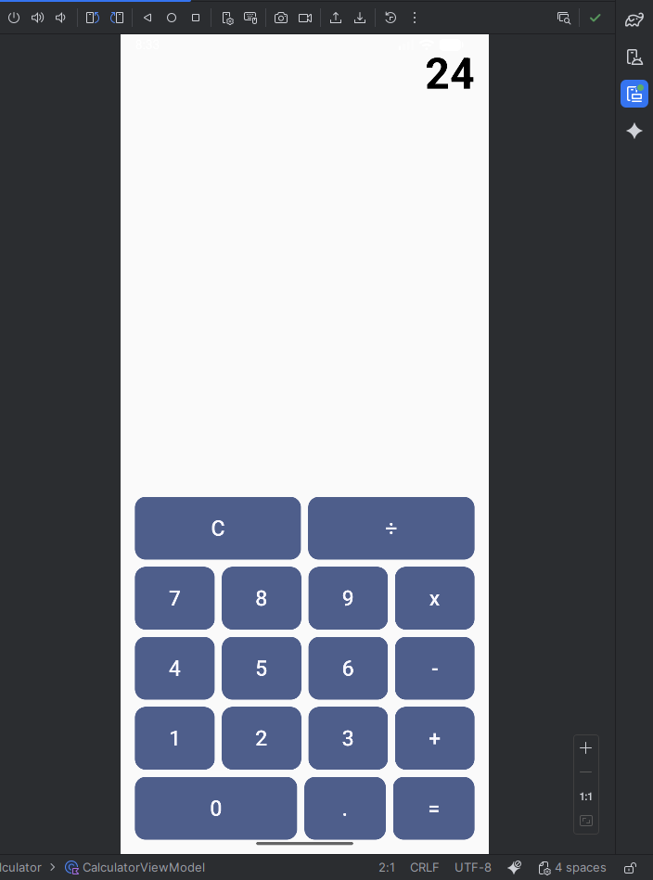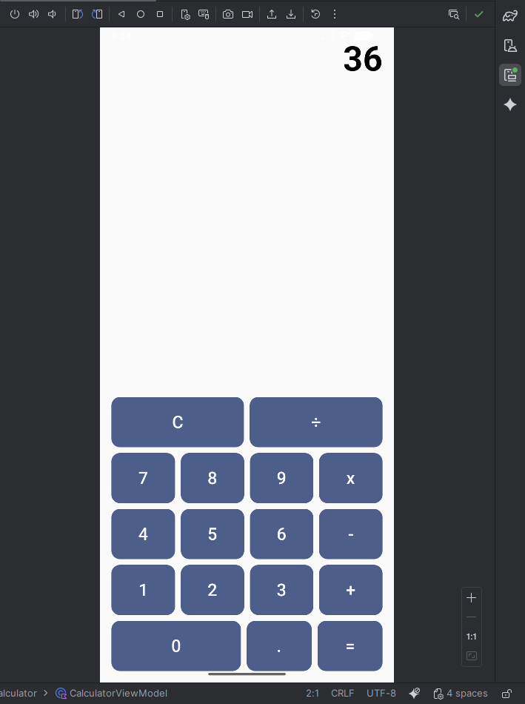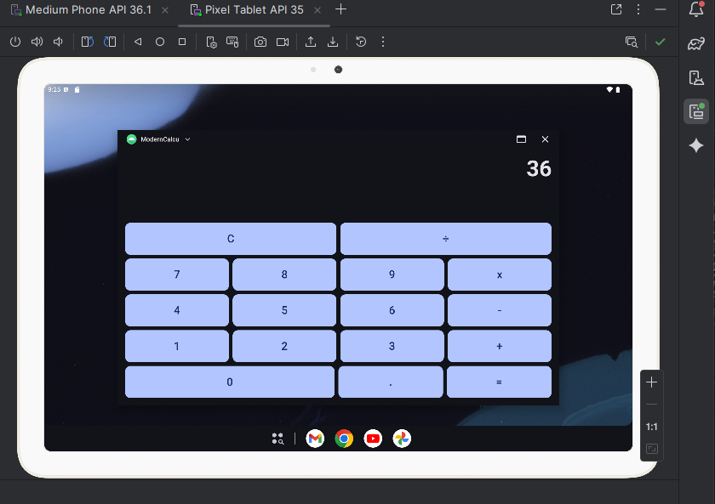
References:
Android Studio. (n.d.). Custom Design Systems in compose : Jetpack Compose : android developers. Android Developers. https://developer.android.com/develop/ui/compose/designsystems/custom
Public GitHub Repository:
